
Public Policy Strategies in Addressing Poverty and Social Inequality in Indonesia
Nisa Lestari^{1*}, Nabil Alam², Ade Yusfiani Ginova³, Inka Nusamuda Pratama⁴
¹²³⁴Universitas Muhammadiyah Mataram, Indonesia

A R T I C L E I N F O

Article history:
Received August 09, 2025
Revised September 10, 2025
Accepted September 20, 2025
Available online September 25, 2025

Keywords:
Poverty Alleviation; Social Inequality; Public Policy

A B S T R A C T
This study aims to identify, evaluate, and formulate effective public policy strategies to address poverty and social inequality in Indonesia simultaneously, in an integrated manner, and with a focus on sustainable development. Using a qualitative approach with the Systematic Literature Review (SLR) method, this study analyzes various relevant research results from the Dimensions and Scopus databases for the period 2020–2025. Inclusion criteria include reputable scientific articles that explicitly discuss public policy strategies related to poverty and inequality in Indonesia. The findings indicate that existing policies are still partial, not integrated across sectors and regions, and lack responsiveness to a multidimensional approach to poverty. This study emphasizes the importance of integrating adaptive social protection, utilizing longitudinal data, and learning from international practices, particularly rural revitalization in China, to support the transformation of social interventions at the local level. The proposed strategic recommendations include strengthening the implementation of the Village Law, inclusive agrarian reform, and integrating SDGs principles into national policies. This research contributes to closing the conceptual and practical gaps regarding the effectiveness of evidence-based social policies in reducing poverty and structural inequality in Indonesia.

- INTRODUCTION
In general, poverty remains a persistent social problem that warrants ongoing study. This is not only because poverty has long existed and remains a part of society's reality, but also because its symptoms are increasing in line with the multidimensional crisis still facing the Indonesian nation (Fardi & Pratama, 2023). One contributing factor to poverty that often receives little attention is the impact of disasters or disease outbreaks. The COVID-19 pandemic has had a significant impact. These impacts include rising unemployment, declining productivity at both the individual and corporate levels, and the emergence of new poor groups, which overall increases the number of poor people (I. N. Pratama, 2023b). Various interrelated factors can also cause poverty. First, natural and economic factors such as natural disasters, limited resources, and economic instability can directly impact people's income and well-being, thereby increasing the risk of falling into poverty (I. N. Pratama, 2023).
Poverty and social inequality are two interrelated phenomena that have a broad impact on human development. Poverty can no longer be understood narrowly as a lack of income, but rather as a multidimensional condition encompassing limited access to education, health care, decent work, and social and political participation (Hababil et al., 2024). Meanwhile, social inequality refers to the unequal distribution of resources, opportunities, and development outcomes, both within and between individuals and regions. In the context of inclusive and sustainable development, a comprehensive understanding of these two variables is essential for developing effective and contextually relevant public policy strategies (Deni, 2023).
Public policy is a strategic instrument for the state to regulate and distribute resources equitably, while simultaneously addressing the structural inequalities that give rise to poverty. Social protection, as part of public policy, serves to guarantee the fundamental rights of citizens through social security mechanisms, social assistance, and subsidies targeting vulnerable groups (Kenney et al., 2022). Within this framework, policy effectiveness is primarily determined by the design of interventions, implementation capacity, data availability, and sensitivity to the surrounding social and cultural context. Therefore, public policy strategies to address poverty and social inequality must be flexible, evidence-based, and responsive to local and global dynamics (Riyanto, 2025).
Evaluations of public policy strategies demonstrate the complex dynamics between implementation success and failure. The most significant challenges often arise at the implementation stage, primarily due to limited resources, high workforce turnover, and a lack of training for policy implementers (Kenney et al., 2022). Furthermore, the success of a policy is heavily influenced by thoughtful design and broad stakeholder engagement (Selepe, 2023). However, the use of scientific evidence to assess policy effectiveness remains challenging, given conflicting findings. Examples include minimum unit pricing (MUP) policies in Scotland and Australia, which have yielded varying evaluation results, highlighting the importance of a context-based approach in interpreting policy effectiveness (Robinson et al., 2023; Rayanakorn et al., 2022).
The limitations of poverty measurement, which focuses solely on income, have encouraged the development of a multidimensional approach. This approach emphasizes the importance of non-monetary indicators such as education, health, and standard of living as integral dimensions of poverty (Zulkifli & Abidin, 2023). However, this approach also faces methodological challenges, such as the selection of relevant indicators and the limitations of the weighting system used in the Multidimensional Poverty Index (MPI), which is considered not to accurately reflect the subjective experiences of people experiencing poverty (Macció & Mitchell, 2023; de Silva & Premaratna, 2023). Therefore, more accurate, representative, and contextual data collection is needed. Furthermore, policy interventions need to be directed at groups and regions often overlooked by conventional indicators, such as informal settlements and refugee groups (Lyons & Kass-Hanna, 2021); (Opaluwa et al., 2022).
The COVID-19 pandemic has exacerbated global poverty, with projections of up to 100 million people entering the extreme poverty category (Valensisi, 2020). Developing countries have experienced income losses of over US$220 billion, with the majority of these losses falling on groups lacking adequate social protection (Saunders & Evans, 2020). In India, an estimated 150–199 million people have fallen into poverty due to economic disruption, particularly in rural areas (Ram & Yadav, 2021). In this context, various intervention strategies have been implemented, including strengthening social security, ensuring food security, and providing direct assistance to support the lives of people experiencing poverty during lockdowns (Pereira & Oliveira, 2020; Buheji et al., 2020). This pandemic highlights the need to transform social protection systems to better prepare for future similar crises.
Based on a literature review and previous empirical findings, a research gap remains in the integration of public policies that are cross-sectoral, cross-regional, and responsive to a multidimensional approach to poverty. Many strategies remain partial, unsustainable, and not entirely based on accurate local data. Furthermore, few studies have examined how international practices and the SDGs framework can be adapted to Indonesia's social policy system in a contextually relevant manner. Therefore, this research aims to identify, evaluate, and formulate Public Policy Strategies to Address Poverty and Social Inequality in Indonesia in a simultaneous, integrated, and sustainable development-oriented manner.
- METHOD
This research employs a qualitative study approach, utilizing a Systematic Literature Review (SLR) methodology. This method is used to identify, evaluate, and interpret all relevant research findings on Public Policy Strategies to Address Poverty and Social Inequality in Indonesia. This approach aims to systematically collect and analyze data from various relevant sources, providing an in-depth understanding of the topic under study. The data in this study are sourced from the Dimensions (https://app.dimensions.ai) and Scopus (https://www.scopus.com) databases, with publication intervals spanning the last six years to ensure that the data used are current and relevant to public policy strategies addressing poverty and Social Inequality in Indonesia.
Data eligibility criteria in this study were established to ensure that only relevant and high-quality literature was analyzed. These criteria include (1) scientific articles published in reputable national and international journals; (2) studies specifically discussing Public Policy Strategies to Address Poverty and Social Inequality in Indonesia; (3) publications published in the last six years (2020-2025); (4) articles available in full text and in English or Indonesian. The research procedure is shown in Figure 1.
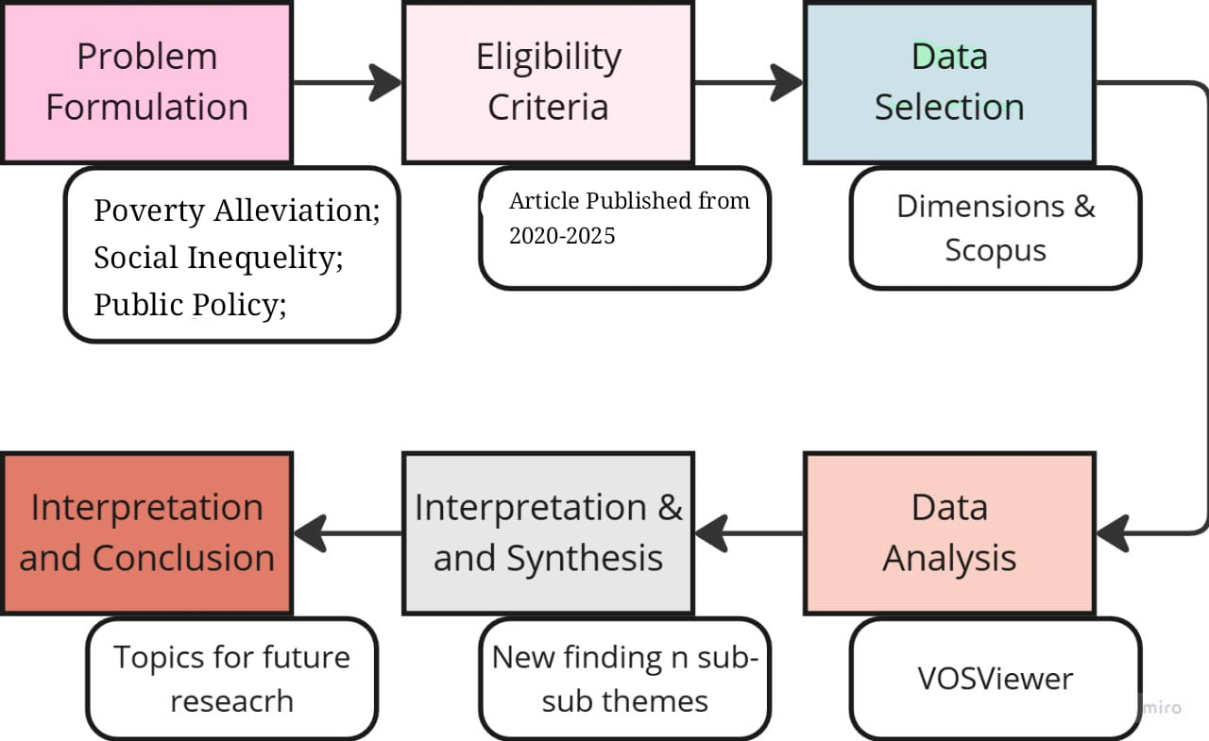
Figure 1. research procedures
Figure 1 illustrates the stages of this research, which included problem formulation, determining eligibility criteria, data selection, data analysis, data interpretation and synthesis, and concluding. The problem formulation stage was crucial for narrowing the topic to Public Policy Strategies in Addressing Poverty and Social Inequality in Indonesia. Eligibility criteria were established to filter data that matched the topic using relevant keywords, such as "(Poverty Alleviation and Social Inequality and Public Policy) OR (Poverty Alleviation AND Social Inequality AND Public Policy)." Data was then selected from the Dimensi database, and filters were applied to data published within the last six years (2020-2025). The collected data were then imported into VOSviewer software to visualize the relationships between keywords and themes in this study. The results of the data visualization and analysis from VOSviewer were interpreted to explain key variables in public policy strategies addressing poverty and Social Inequality in Indonesia.
- RESULT AND DISCUSSION
- Data Selection Results
The search results in the indexer database identified a total of 140,222 records, including 34,587 open-access records and the remainder closed-access records. Of these 34,587 records, 23,422 were articles, and 11,161 were books and proceedings. This left 13,693 records for analysis in the next stage. The distribution of these records is shown in Figure 2.
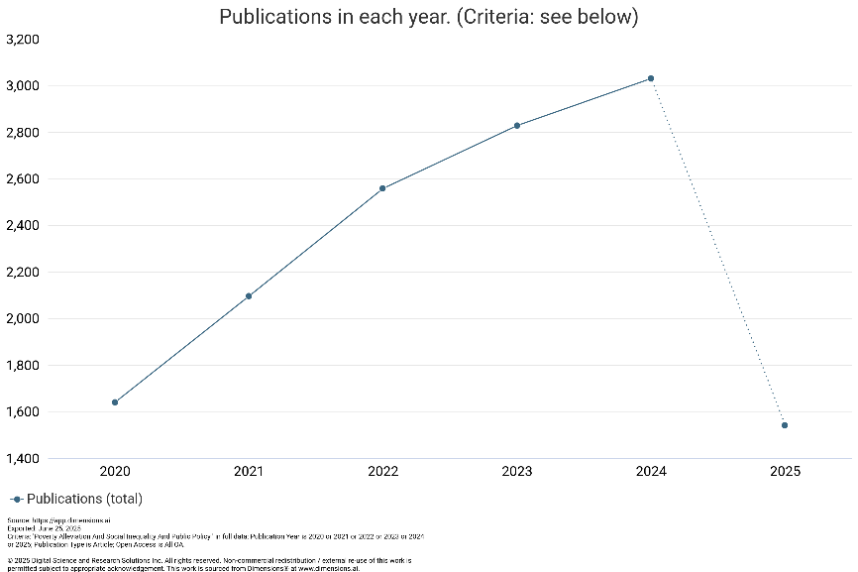
Figure 2. Distribution of the amount of data over the last five years
Figure 2 shows the number of publications on the topic "Poverty Alleviation and Social Inequality and Public Policy" from 2020 to 2025. The number of publications has increased consistently since 2020, reaching its peak in 2024. In 2020, the number of publications was recorded at around 1,650, then increased significantly every year: around 2,100 in 2021, around 2,550 in 2022, to nearly 2,850 in 2023, and finally reaching a peak of around 3,050 publications in 2024. This trend shows an increase in academic attention to the issues of poverty alleviation, social inequality, and public policy during the first five years. However, a sharp decline was observed in 2025, with the number of publications reaching only around 1,550, even lower than in 2020. This decline is due to incomplete publication data for 2025, as the data was exported mid-year (June 2025), resulting in many publications not yet being recorded or officially published. Therefore, the 2025 data should be treated as preliminary and not used for final annual trend comparisons.
- Network Visualization of Data
The selected data were then visualized using VOSviewer to examine the research variables and their relationships. The resulting visualization is shown in Figure 3.
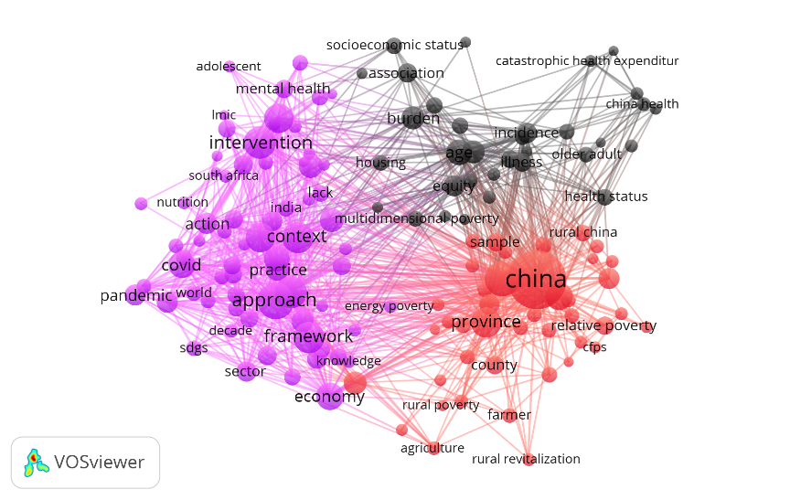
Figure 3. Network visualization of research variables
Generation Figure 3 is a network visualization of all variables studied over the past six years, depicting three distinct color clusters: purple, black, and orange, The interpretation of each variable is as follows:
- Purple Cluster (Intervention Approach and Global Context)
This cluster focuses on intervention, context, approach, framework, pandemic, mental health, COVID-19, action, SDGs, nutrition, practice, sector, South Africa, India, and the world. This cluster represents conceptual approaches and practices of social interventions in a global context, particularly in relation to the challenges posed by the COVID-19 pandemic and the Sustainable Development Goals (SDGs). Mental health and nutrition issues in vulnerable groups (such as adolescents) are of primary concern, with an emphasis on cross-sectoral approaches and multidisciplinary frameworks. Developing countries such as India and South Africa emerge as important empirical loci in the literature.
- Black Cluster (Social Determinations and Multidimensional Dimensions of Poverty)
This cluster focuses on terms such as age, burden, equity, multidimensional poverty, socioeconomic status, illness, incidence, association, catastrophic health expenditure, older adult, housing, and health status. This cluster maps the relationship between poverty dimensions and social determinant indicators, such as age, socioeconomic status, and health. There is significant focus on the concept of multidimensional poverty and the burden of catastrophic health expenditure, particularly among older adults. Inequality in access to housing and healthcare is also an important variable analyzed using associative and regressive approaches.
- Orange Cluster (Geographic and Spatial Focus on Poverty in China)
This cluster is dominated by China, provinces, counties, rural China, relative poverty, CFPs, rural revitalization, farmers, agriculture, and economy. This cluster highlights studies that focus on the regional context in China, particularly on poverty alleviation strategies in rural areas. Rural revitalization programs and agricultural transformation are key keywords, supported by microdata such as the China Family Panel Studies (CFPS). This discourse also focuses on the dynamics between provinces and districts, as well as the influence of economic policies on farmer conditions and relative poverty.
Based on this cluster division, researchers can conduct more in-depth studies on the following topics.
- Transforming Social Intervention Approaches in Indonesia: From the Pandemic to the Sustainable Development Agenda
The COVID-19 pandemic has prompted a re-evaluation of social policies aimed at poverty intervention, highlighting the importance of adaptive strategies to address increasingly complex vulnerabilities. In this context, the integration of social protection mechanisms is crucial, particularly through the implementation of schemes such as Temporary Basic Income (TBI), which has the potential to alleviate the economic burden on people with low incomes and near-poor at a relatively low cost, around 0.27% to 0.63% of GDP in developing countries (Barron et al., 2022). Furthermore, the pandemic has underscored the importance of universal health coverage and robust social protection systems in addressing inequities in access to health services and supporting vulnerable groups, including those facing systemic discrimination (Gray Molina et al., 2022; Tan et al., 2023).
On the other hand, the integration of the Sustainable Development Goals (SDGs) into poverty reduction strategies further underscores the need for a multidimensional approach, encompassing aspects such as income, health, education, and living standards. Practices in countries like China demonstrate the effectiveness of using data-driven, multidimensional indicators in directing funding allocations that are more focused on local needs (Yang et al., 2022). Local governments play a crucial role in implementing SDG-based strategies by optimizing regional resources and fostering community participation, particularly in areas such as health, education, and employment. Furthermore, this approach reinforces global commitments to economic and social rights and sustainability principles as affirmed in the 2030 Agenda, while also encouraging more accountable governance (M. Y. J. Pratama & Zubaidah, 2024; Padmakanthi, 2023).
The interpretation of these findings suggests that a transformation in Indonesia's social intervention approach is needed to strengthen flexible and inclusive social protection, taking into account the non-monetary dimensions of poverty. The pandemic has demonstrated that policies combining public health and social security interventions can improve public compliance without sacrificing economic stability. Therefore, Indonesia needs to accelerate the integration of SDG principles into national policies across sectors and regions. This approach is not only relevant in the context of post-pandemic recovery but also essential for strengthening the foundations of equitable, sustainable development, which focuses on reducing social inequality in the long term.
- Structural Inequality and Social Determinants of Poverty in Indonesia.
Social determinants such as age, socioeconomic status (SES), and household expenditure burden play a central role in explaining health disparities, particularly among vulnerable populations. For example, older adults have higher healthcare needs, which directly impacts increased household expenditures. In Vietnam, 86.3% of household health expenditures come from out-of-pocket costs (OOPHE) for older adults, with 12.2% experiencing financial stress due to this burden (Giang et al., 2022). Low socioeconomic status is also strongly correlated with poor health outcomes and high levels of financial toxicity, with individuals in the lowest SES quartile experiencing a prevalence of financial toxicity of up to 68%, significantly higher than the 15% in the highest SES group (Valero-Elizondo et al., 2022). Factors such as economic stability, education, and residential conditions form a key foundation for health disparities, creating an accumulation of intertwined vulnerabilities that contribute to these disparities.
On the other hand, a multidimensional understanding of poverty offers a more comprehensive perspective for designing effective policy interventions. Multidimensional poverty is measured not only through income indicators but also through dimensions of health, education, and standard of living (Zulkifli & Abidin, 2023). Measurement tools such as the Multidimensional Poverty Index (MPI) and the Alkire-Foster method enable evidence-based decision-making through more specific measurements of deprivation (De Rosa, 2022; Saddique et al., 2023). Case studies in South Africa and Pakistan show that regional disparities can be identified through specific indicators such as access to sanitation, transportation asset ownership, and public services (Jackson & Yu, 2023). Furthermore, demographic factors such as gender, age, and employment status have also been shown to significantly influence multidimensional poverty levels, highlighting the need for policies that are sensitive to population diversity (Saddique et al., 2023).
The interpretation of these findings suggests that structural inequality and the social determinants of poverty in Indonesia cannot be addressed solely through a one-dimensional, income-based approach. The complexity of age, socioeconomic status, and health expenditure must be understood as part of a system that interplays and exacerbates inequality. Therefore, Indonesia needs to adopt a multidimensional, indicator-based policy approach that addresses the root causes of poverty, including access to health services, education, and housing conditions. This approach will enable the formulation of interventions that are more adaptable to regional variations and demographic characteristics, while strengthening the foundation of inclusive policies aimed at reducing structural social inequality.

- Global Lessons for National Strategy: Reflections on the Case of China and Its Adaptation in Indonesia
Rural revitalization and agricultural reform are crucial strategies in addressing socioeconomic inequality in Indonesia. The transformation of the agricultural sector, marked by a shift to non-agricultural sectors, has persistently exacerbated rural poverty in various provinces (Abduh, 2023). In this context, strengthening agricultural business performance has proven effective in improving farmer welfare and is a crucial element in poverty alleviation (Boni, 2022). However, unequal land ownership remains a structural barrier that gives rise to agrarian conflicts and human rights violations (Earlene & Djaja, 2023). Effective agrarian reform is necessary to achieve equitable land redistribution, laying the foundation for social justice. Furthermore, the Village Law has strengthened the role of village governments in agricultural development and food sovereignty, despite challenges in institutional capacity and global market pressures (Sujito & Ghofur, 2023). The fragmentation of the agrarian movement and the tendency for co-optation by political elites also pose challenges to realizing a transformative revitalization agenda (White et al., 2023).
To support policies that are inclusive and responsive to local needs, longitudinal data-driven and microanalytical approaches are essential. Longitudinal data enable the monitoring of changes in social indicators, such as educational participation and health status, over time, while simultaneously improving the accuracy of policy evaluations (Ramberg & Watkins, 2020; Pattaro et al., 2020). Longitudinal studies also reveal the impact of social investment policies on family dynamics and fertility, which is crucial for long-term planning (Billingsley et al., 2022). Meanwhile, microanalysis provides granular insights into policy implementation mechanisms and their impacts on individuals and local communities (Capano & Toth, 2023). Through microdata analysis, policies can be more effectively targeted to those most in need, thereby increasing the effectiveness and efficiency of development strategies (Hoff et al., 2022).
The interpretation of these findings suggests that lessons learned from global practices, particularly those in China, can provide significant inspiration for formulating Indonesia's national strategy, particularly in rural revitalization and data-driven development. China's success in integrating agrarian policies, rural development, and longitudinal databases such as the CFPS serves as a key example of how the success of interventions hinges on consistent governance and data accuracy. In the Indonesian context, strengthening databases such as PODES, Susenas, and Sakernas, as well as empowering village institutions, are crucial to promoting inclusive, adaptive, and contextually relevant policy design. This adaptation requires cross-sectoral synergy between agrarian reform, village capacity building, and robust information systems to ensure the sustainable implementation of the agenda for reducing social inequality and rural poverty.
- CONCLUSION AND RECOMMENDATION
Transforming the approach to social interventions in Indonesia requires comprehensive integration between adaptive social protection, a multidimensional approach to poverty, and the use of longitudinal data and community-based development practices. Recent findings suggest that effective responses to poverty and social inequality must go beyond purely monetary approaches and instead prioritize interventions that consider social determinants such as age, socioeconomic status, expenditure burdens, and spatial inequality. Furthermore, lessons learned from global practices, such as China's rural revitalization model, emphasize the importance of strong, evidence-based governance in developing inclusive and sustainable development strategies. Therefore, integrating SDG principles, agrarian reform, and strengthening local capacity needs to be an integral part of Indonesia's public policy agenda. Urgent research agendas include region-based longitudinal studies on the effectiveness of post-pandemic social protection programs in reducing multidimensional poverty, as well as evaluative research on the implementation of the Village Law in supporting agricultural revitalization and the equitable distribution of agrarian assets. Both research projects are crucial to ensuring that social policies effectively reach the most vulnerable groups and narrow the gap in structural inequality at the local level.
- REFERENCES
Abduh, M. (2023). Indonesia Agricultural Transformation: How Far? Where Would It Go? In Jurnal Perencanaan Pembangunan: The Indonesian Journal of Development Planning (Vol. 7, Issue 1). https://doi.org/10.36574/jpp.v7i1.366
Barron, G. C., Laryea-Adjei, G., Vike-Freiberga, V., Abubakar, I., Dakkak, H., Devakumar, D., Johnsson, A., Karabey, S., Labonté, R., Legido-Quigley, H., Lloyd-Sherlock, P., Olufadewa, I. I., Ray, H. C., Redlener, I., Redlener, K., Serageldin, I., Lima, N. T., Viana, V., Zappone, K., … Karadag, O. (2022). Safeguarding people living in vulnerable conditions in the COVID-19 era through universal health coverage and social protection. The Lancet Public Health, 7(1), e86–e92. https://doi.org/10.1016/S2468-2667(21)00235-8
Billingsley, S., Neyer, G., & Wesolowski, K. (2022). Social Investment Policies and Childbearing Across 20 Countries: Longitudinal and Micro-Level Analyses. European Journal of Population, 38(5), 951–974. https://doi.org/10.1007/s10680-022-09626-3
Boni, Y. (2022). Agricultural Development’s Influence on Rural Poverty Alleviation in the North Buton Regency, Indonesia—The Mediating Role of Farmer Performance. Economies, 10(10). https://doi.org/10.3390/economies10100240
Buheji, M., da Costa Cunha, K., Beka, G., Mavrić, B., Leandro do Carmo de Souza, Y., Souza da Costa Silva, S., Hanafi, M., & Chetia Yein, T. (2020). The Extent of COVID-19 Pandemic Socio-Economic Impact on Global Poverty. A Global Integrative Multidisciplinary Review. American Journal of Economics, 10(4), 213–224. https://doi.org/10.5923/j.economics.20201004.02
Capano, G., & Toth, F. (2023). Health policy under the microscope: a micro policy design perspective. Frontiers in Public Health, 11(June), 1–10. https://doi.org/10.3389/fpubh.2023.1180836
De Rosa, D. (2022). Are Italians Getting Multidimensionally Poorer? Evidence on the Lack of Equitable and Sustainable Well-Being. Italian Economic Journal, 8(1), 145–174. https://doi.org/10.1007/s40797-021-00159-y
de Silva, H. V. S., & Premaratna, S. P. (2023). An approach to determine multi-dimensional poverty index for Sri Lanka: a comparative study. Sri Lankan Journal of Banking and Finance, 6(1).
Deni, A. (2023). Kebijakan Publik (Formulasi, Implementasi, Evaluasi, dan Analisis). Cendikia Mulia Mandiri.
Earlene, F., & Djaja, B. (2023). Implikasi kebijakan reforma agraria terhadap ketidaksetaraan kepemilikan tanah melalui lensa hak asasi manusia. Tunas Agraria, 6(2), 152–170. https://doi.org/10.31292/jta.v6i2.223
Fardi, M., & Pratama, I. N. (2023). Transparansi Pendataan Program Bantuan Sosial Tunai dalam Penanggulangan Kemiskinan di Lingkungan Bebidas Kelurahan Pegesangan Kota Mataram. Journal of Social and Policy Issues, 150–155.
Giang, N. H., Vinh, N. T., Phuong, H. T., Thang, N. T., & Oanh, T. T. M. (2022). Household financial burden associated with healthcare for older people in Viet Nam: a cross-sectional survey. Health Research Policy and Systems, 20(1), 1–16. https://doi.org/10.1186/s12961-022-00913-3
Gray Molina, G., Montoya-Aguirre, M., & Ortiz-Juarez, E. (2022). Temporary Basic Income in Times of Pandemic: Rationale, Costs and Poverty-Mitigation Potential. Basic Income Studies, 17(2), 125–154. https://doi.org/10.1515/bis-2020-0029
Hababil, M. P., Firdaus, M. K., Nazhmi, N., Hamdani, M. D., Alghifary, M. R., & Fadilla, A. (2024). Analisis Pengaruh Pemerataan Ekonomi Dalam Upaya Menghapus Ketimpangan Sosial-Ekonomi Antar Masyarakat. Journal of Macroeconomics and Social Development, 1(4), 1–9.
Hoff, R., Maltzahn, N., Hasting, R. L., Merkus, S. L., Undem, K., Kristensen, P., Mehlum, I. S., & Gran, J. M. (2022). An initiative for a more inclusive working life and its effect on return-to-work after sickness absence: a multistate longitudinal cohort study. BMJ Open, 12(11), 1–10. https://doi.org/10.1136/bmjopen-2022-062558
Jackson, S., & Yu, D. (2023). Re-examining the multidimensional poverty index of South Africa. Social Indicators Research, 166(1), 1–25.
Kenney, E. L., Mozaffarian, R. S., Ji, W., Tucker, K., Poole, M. K., DeAngelo, J., Bailey, Z. D., Cradock, A. L., Lee, R. M., & Frost, N. (2022). Moving from Policy to Practice for Early Childhood Obesity Prevention: A Nationwide Evaluation of State Implementation Strategies in Childcare. International Journal of Environmental Research and Public Health, 19(16). https://doi.org/10.3390/ijerph191610304
Lyons, A. C., & Kass-Hanna, J. (2021). A multidimensional approach to measuring vulnerability to poverty of Syrian refugees in Lebanon. The Economic Research Forum (ERF). Working Paper, the University of Illinois at Urbana-Champaign, Dokki, Egypt.
Macció, J., & Mitchell, A. (2023). Multidimensional Poverty Measurement in Segregated Cities: Evidence from the City of Buenos Aires. Desarrollo y Sociedad, 2023(93), 101–137. https://doi.org/10.13043/DYS.93.3
Opaluwa, H. I., Opeyemi, G., Danjuma, S., & Adeyemi, M. (2022). Assessment of multidimensional poverty in Zone A agricultural development project area of Kogi State, Nigeria. Journal of Agriculture and Food Sciences, 19(2), 51–62. https://doi.org/10.4314/jafs.v19i2.6
Padmakanthi, N. P. D. (2023). Sustainable Way to Eradicate Poverty through Social Protection: The Case of Sri Lanka. Social Sciences, 12(7). https://doi.org/10.3390/socsci12070384
Pattaro, S., Bailey, N., & Dibben, C. (2020). Using Linked Longitudinal Administrative Data to Identify Social Disadvantage. In Social Indicators Research (Vol. 147, Issue 3). https://doi.org/10.1007/s11205-019-02173-1
Pereira, M., & Oliveira, A. M. (2020). Poverty and food insecurity may increase as the threat of COVID-19 spreads. Public Health Nutrition, 23(17), 3236–3240. https://doi.org/10.1017/S1368980020003493
Pratama, I. N. (2023a). Dinamika Kemiskinan Di Kota Mataram: Analisis Perubahan Tingkat Kemiskinan Dalam Dekade Terakhir. SEMINAR NASIONAL LPPM UMMAT, 2, 1216–1222.
Pratama, I. N. (2023b). Skema Pengentasan Kemiskinan Ditinjau Dari Perspektif Collaborative Governance Di Kota Mataram. Jurnal Komunikasi Dan Kebudayaan, 10(1), 61–77.
Pratama, M. Y. J., & Zubaidah, S. (2024). Poverty Alleviation Policy Strategy through Sustainability Development Goals (SDGs) and Indonesia’s Economic Resources. KnE Social Sciences, 2024, 52–65. https://doi.org/10.18502/kss.v9i18.16329
Ram, K., & Yadav, S. (2021). The Impact of COVID-19 on Poverty Estimates in India: A Study Across Caste, Class and Religion. Contemporary Voice of Dalit. https://doi.org/10.1177/2455328X211051432
Ramberg, J., & Watkins, A. (2020). Exploring inclusive education across Europe: some insights from the European Agency Statistics on Inclusive Education. FIRE: Forum for International Research in Education, 6(1), 85–101. https://doi.org/10.32865/fire202061172
Rayanakorn, A., Leong, S. L., Chaiprom, P., & Lee, S. W. H. (2022). Cost-effectiveness of Public Health Strategies on COVID-19 Control: A Systematic Review. Progress in Microbes and Molecular Biology, 5(1), 1–26. https://doi.org/10.36877/pmmb.a0000268
Riyanto, W. H. (2025). Model Kelembagaan Daerah dalam Penanganan Kemiskinan. UMMPress.
Robinson, M., Callinan, S., & Taylor, N. (2023). Disentangling the messiness of natural experiments to evaluate public policy. Addiction, 118(9), 1618–1620. https://doi.org/10.1111/add.16265
Saddique, R., Zeng, W., Zhao, P., & Awan, A. (2023). Understanding multidimensional poverty in pakistan: implications for regional and demographic-specific policies. Environmental Science and Pollution Research, Sharma 2019. https://doi.org/10.1007/s11356-023-28026-6
Saunders, M. J., & Evans, C. A. (2020). COVID-19, tuberculosis and poverty: preventing a perfect storm. The European Respiratory Journal, 56(1), 2001348.
Selepe, M. M. (2023). The evaluation of public policy implementation failures and possible solutions. EUREKA: Social and Humanities, 1, 43–53. https://doi.org/10.21303/2504-5571.2023.002736
Sujito, A., & Ghofur, M. (2023). The Nurturing Food Sovereignty from the Peripheral Side: the Village Law and the Soul of Agriculture in Rural Development in Indonesia. Sodality: Jurnal Sosiologi Pedesaan, 10(3), 305–316. https://doi.org/10.22500/10202243672
Tan, S. Y., De Foo, C., Verma, M., Hanvoravongchai, P., Cheh, P. L. J., Pholpark, A., Marthias, T., Hafidz, F., Putri, L. P., & Mahendradhata, Y. (2023). Mitigating the impacts of the COVID-19 pandemic on vulnerable populations: Lessons for improving health and social equity. Social Science & Medicine, 328, 116007.
Valensisi, G. (2020). COVID-19 and Global Poverty: Are LDCs Being Left Behind? European Journal of Development Research, 32(5), 1535–1557. https://doi.org/10.1057/s41287-020-00314-8
Valero-Elizondo, J., Javed, Z., Khera, R., Tano, M. E., Dudum, R., Acquah, I., Hyder, A. A., Andrieni, J., Sharma, G., Blaha, M. J., Virani, S. S., Blankstein, R., Cainzos-Achirica, M., & Nasir, K. (2022). Unfavorable social determinants of health are associated with higher burden of financial toxicity among patients with atherosclerotic cardiovascular disease in the US: findings from the National Health Interview Survey. Archives of Public Health, 80(1), 1–12. https://doi.org/10.1186/s13690-022-00987-z
White, B., Graham, C., & Savitri, L. (2023). Agrarian movements and rural populism in Indonesia. Journal of Agrarian Change, 23(1), 68–84. https://doi.org/10.1111/joac.12506
Yang, D., Luan, W., Yang, J., Xue, B., Zhang, X., Wang, H., & Pian, F. (2022). The contribution of data-driven poverty alleviation funds in achieving mid-21st-Century multidimensional poverty alleviation planning. Humanities and Social Sciences Communications, 9(1). https://doi.org/10.1057/s41599-022-01180-x
Zulkifli, F., & Abidin, R. Z. (2023). The Multi-Dimensional Nature of Poverty: A Review of Contemporary Research. International Journal of Academic Research in Economics and Management Sciences, 12(2), 272–288. https://doi.org/10.6007/ijarems/v12-i2/17260

